Percona Audit log Plugin
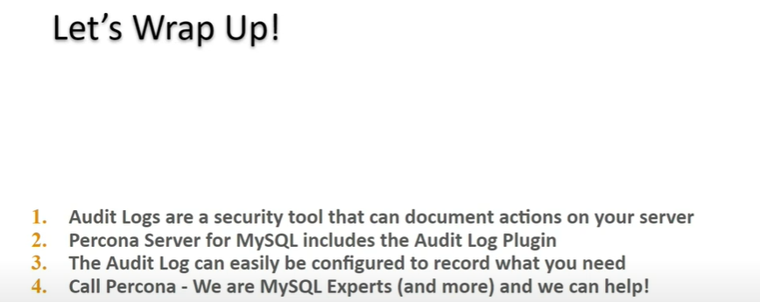

Audit logs are used to determine whom is doing what on a server.
Percona server for Mysql has an Audit log plugin as an Enterprise feature at a community Price
And you will see it the Audit Log Plugin is easy to install and use.

What is the use of audit log?
Audit logs record the occurrence of an event, the time at which it occurred, the responsible user or service, and the impacted entity.

